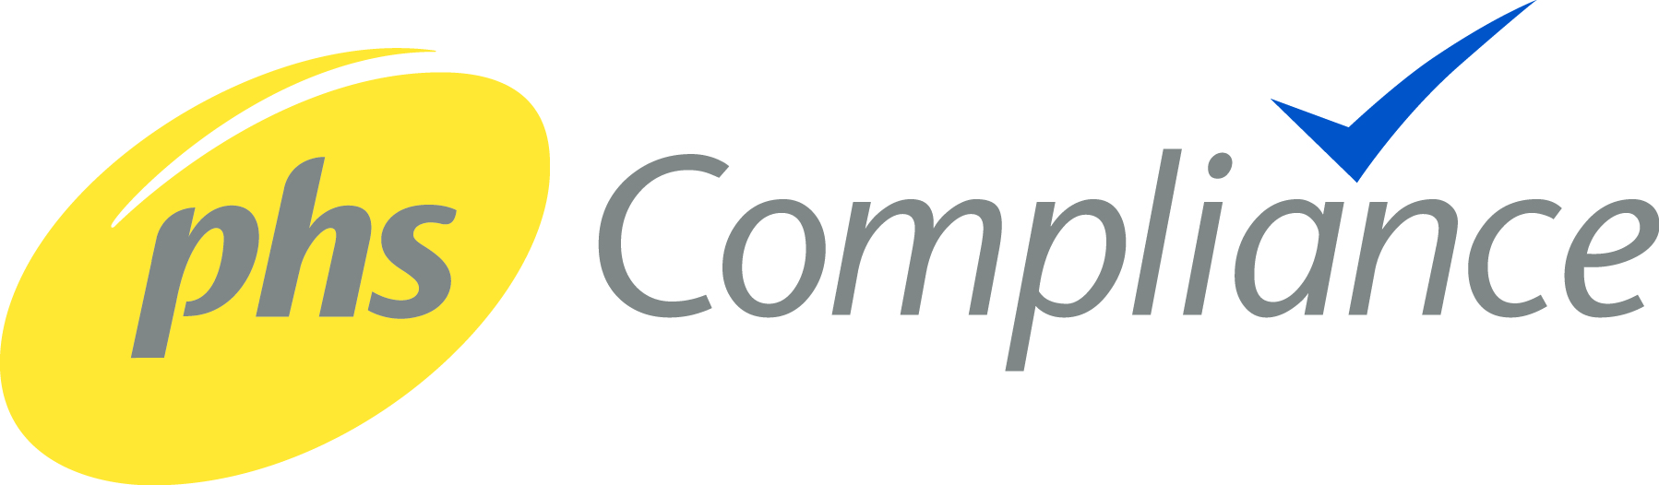

Job Description

Job Title: Head of Health, Safety, Quality, Environment (HSQE), and Technical

Division: PHS Compliance

Location: Golborne Office Warrington – with National Travel

Reports To: Operations Director

About phs

phs Group are the leading hygiene services provider in the UK, Spain, and Ireland. With over 120,000 customers in over 300,000 locations, supporting everything from restaurants to offices, and from hospitals to schools, we meet the needs of up to 100 million people.
Our core business is healthcare, washroom and floorcare hygiene, but alongside our hygiene experts we have several specialist businesses meeting the needs of specific organisations. We’re seeking a dynamic, hands-on Head of HSQE and Technical who can drive and deliver safety practises and “get stuff done” but also help build and deliver our longer-term strategic plan – to support Compliance being the market leading business in the facilities management compliance sector.

About Compliance

phs Compliance is the UK's leading provider of statutory electrical fire safety testing and remedial services, keeping businesses and public sector organisations of all sizes safe and compliant with the latest statutory safety regulations. From business engineering services to compliance engineering, we have everything you need to meet your workplace safety compliance requirements and receive the appropriate building regulations statutory inspections compliance certificate.

Purpose of the Role

Reporting directly to the Operations Director, the Head of HSQE and Technical for Compliance will be responsible for inspiring, leading, motivating and developing the HSQE and technical training to the operational teams of Compliance to ensure they deliver exceptional standards of compliance and operational excellence. They will also be accountable for shaping the future compliance and training strategy, ensuring alignment across the business to maintain the highest levels of health, safety, quality, and environmental performance.
The role carries direct operational leadership responsibility for HSQE functions, compliance frameworks, and technical within Compliance. The successful candidate will also be expected to provide overall functional leadership and support, fostering a collaborative culture and driving continuous improvement initiatives across all areas of the business

To understand interpret and apply relevant laws, regulations, certifications and best practice including technologies, systems and processes and to support the business in their effective implementation.

To develop strong and effective working relationships with the Group Health and Safety and Learning and Development teams.

Key Responsibilities:
- Develop and deliver a Health, Safety, technical service quality and Environment strategy, that delivers the sustainable development and corporate social responsibility standards at PHS.
- Lead all H&S activity within phs Compliance.
- Actively monitor employee engagement and participation in safety compliance.
- Incident investigation review and root cause analysis.
- Proactively contribute to training activities in relation to quality, health, safety and environmental management.
- Promote management ownership of the PHS Compliance safety, environmental and quality management system, working in collaboration with the Group HSQE.
- Understand all safety, environmental and product legislation applicable to the business, and support site teams with guidance to comply.
- Develop, implement, and maintain safety policies, procedures, and safe systems of work.
- Provide internal audits that meet ISO standard requirements in relation to safety, quality and environmental matters.
- Support teams during external accreditation audits including but not limited to ISO 9001, ISO 45001, ISO 9001, CHAS and Safe contractor as per the organisation’s requirement.
- Ensuring all mandatory H&S training is up to date
- Effectively manage the organisation’s technical function to ensure best practices are followed, SOPs implemented and a robust internal quality audit and technical verification schedule is implemented and adhered to aligned with British standard and management system requirements.
- Ownership and record of all technical certification qualifications across the organisation to ensure requirements are met for all roles of employment.
- To review and identify opportunities to drive continuous improvement and innovation in all aspects of technology, systems and processes to ensure the organisation is effective and efficient in all service line offerings.
- Identify design and implement change programs identified by legal, commercial or continual improvement requirements.
- Maintain professional competence to Tech IOSH and PIEMA.

Essential Requirements:

- IOSH Managing Safely.
- Relevant electrical qualification (e.g. NVQ Level 3, City & Guilds, or equivalent) with a minimum of 5 years electrical management experience.
- Strong working knowledge of UK electrical safety legislation and standards
- Experience acting as an Electrical Authorised Person or Duty Holder
- A concise communication style, and a robust and effective approach

Desirable attributes;

- NEBOSH General Certificate (or equivalent H&S qualification) or willingness to work towards
- MIET member of the IET or willing to work towards
- Registered with the engineering council to EngTech or willing to work towards
- TechIOSH member of IOSH or willing to work towards
- Member of IEMA or willing to work towards.
- Lead auditor qualification (ISO 9001).

Personal Characteristics

The successful candidate will understand that success will be driven through strong leadership, and achieve this through:
- Delivery
- Being highly visible within the business
- Setting high standards of performance, whilst inspiring others to perform at their best
- Being approachable and a “champion” of HSQE.
- An ability to take the organisation along with them.
- Able to connect with all colleagues/customers
- A strong grasp of detail, the ability to articulate this detail effectively, and the willingness to go the extra mile to build an effective business case supported by data.

